ANSIBLE ASSIGNMENT

**NAME: Chirudeep Gorle**

**SJSU ID: 016682627**

Software Engineering cohort in Data science

Question:

Deploy three (3) Virtual Machines

Configure Ansible server on ***VM 1***to deploy a webserver *to****VM2***and ***VM3***on port 8080 that displays the message: “Hello World from SJSU”

GITHUB link: <https://github.com/ChirudeepG/CMPE272_Ansible.git>

**Deploying three (3) Virtual Machines**

Deploying 3 VM’s with ubuntu EC2 instances

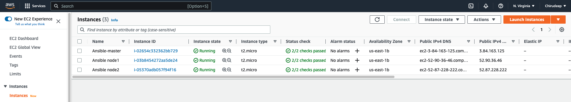

Installing Ansible on Master and installing python on both slave nodes.

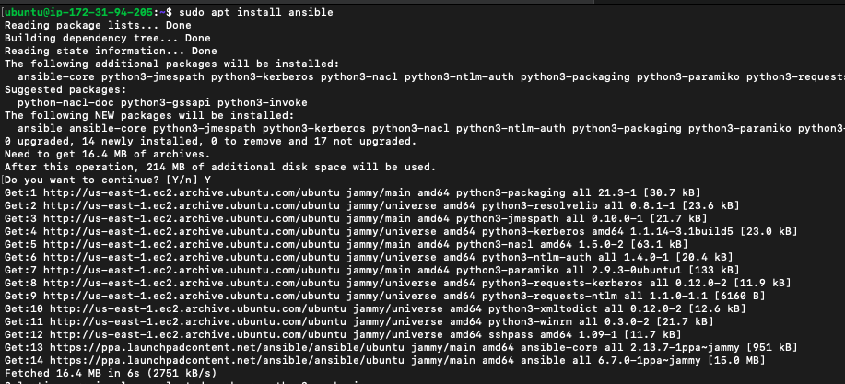

Creating Keygen and adding it in the slave nodes

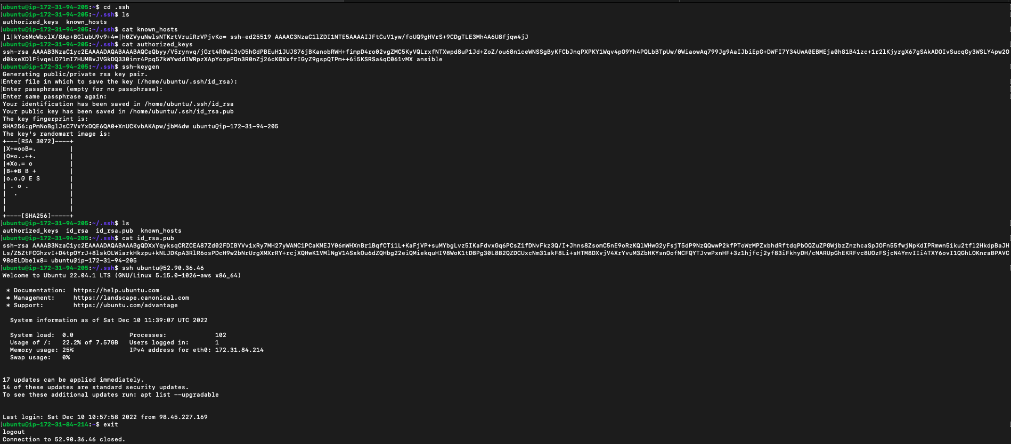

Adding the key in slave nodes

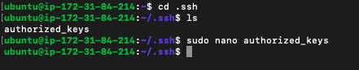

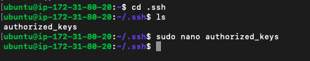

Now we can login directly

Node1

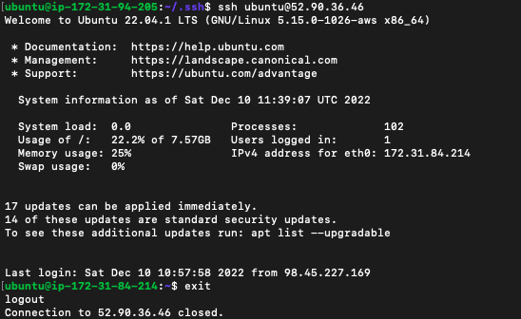

Node2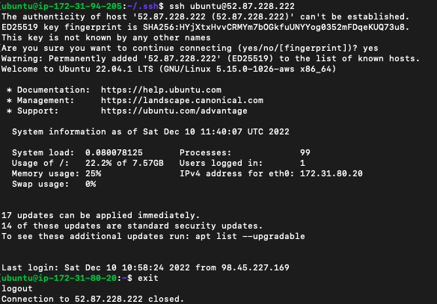

Adding I.p hosts files

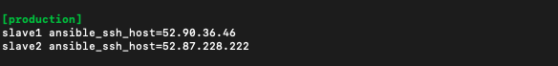

Pinging the slaves

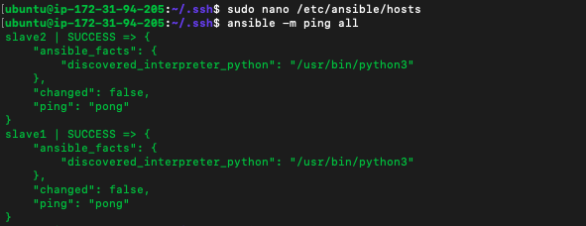

Playbook to deploy apache

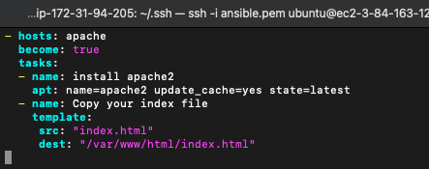

Running the playbook

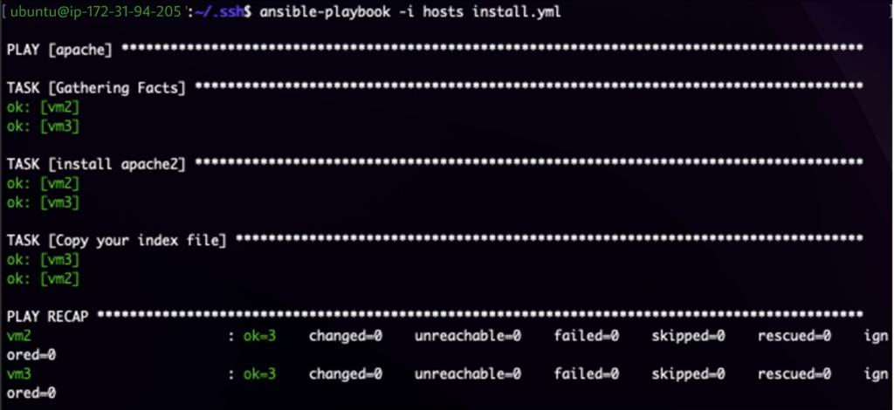

After deploying checking with ip 1:



Checking with 2nd ip address:



Playbook to undeploy apache

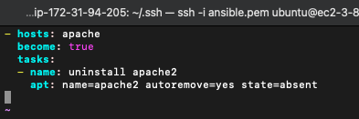

Running the playbook

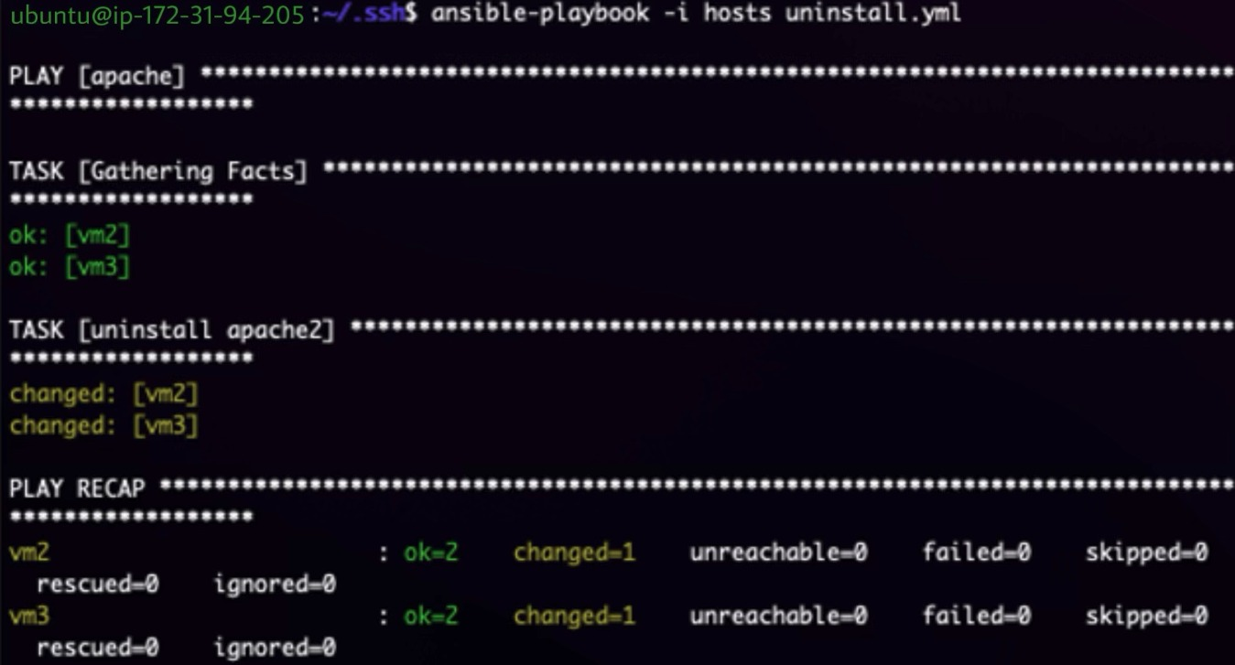

After undeploying apache

Ip adress1

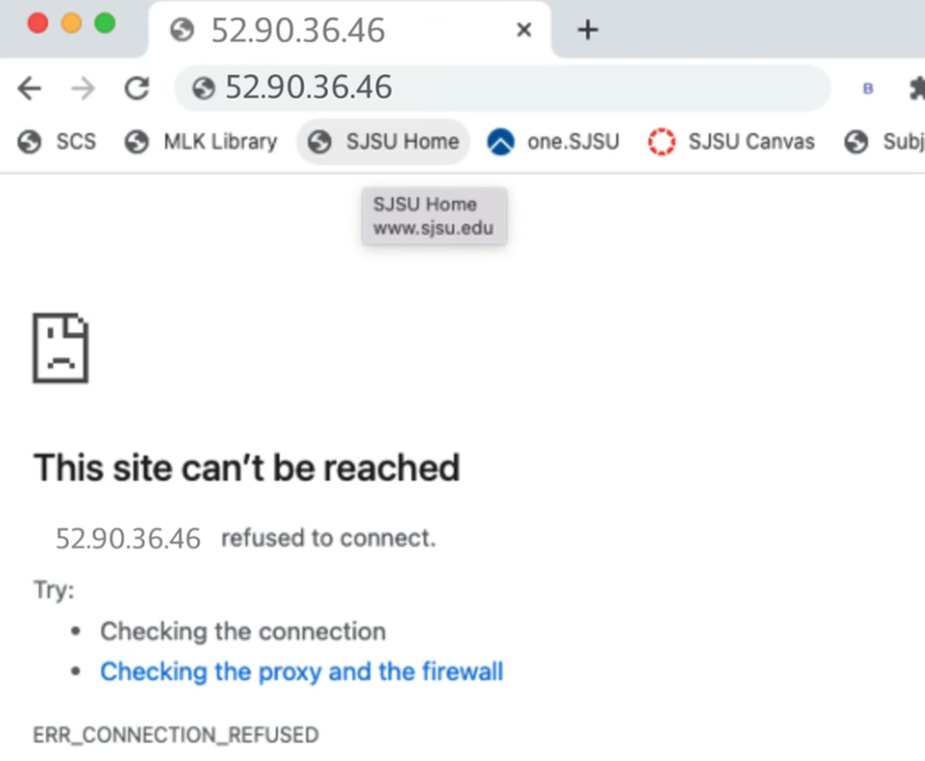

Ip address 2

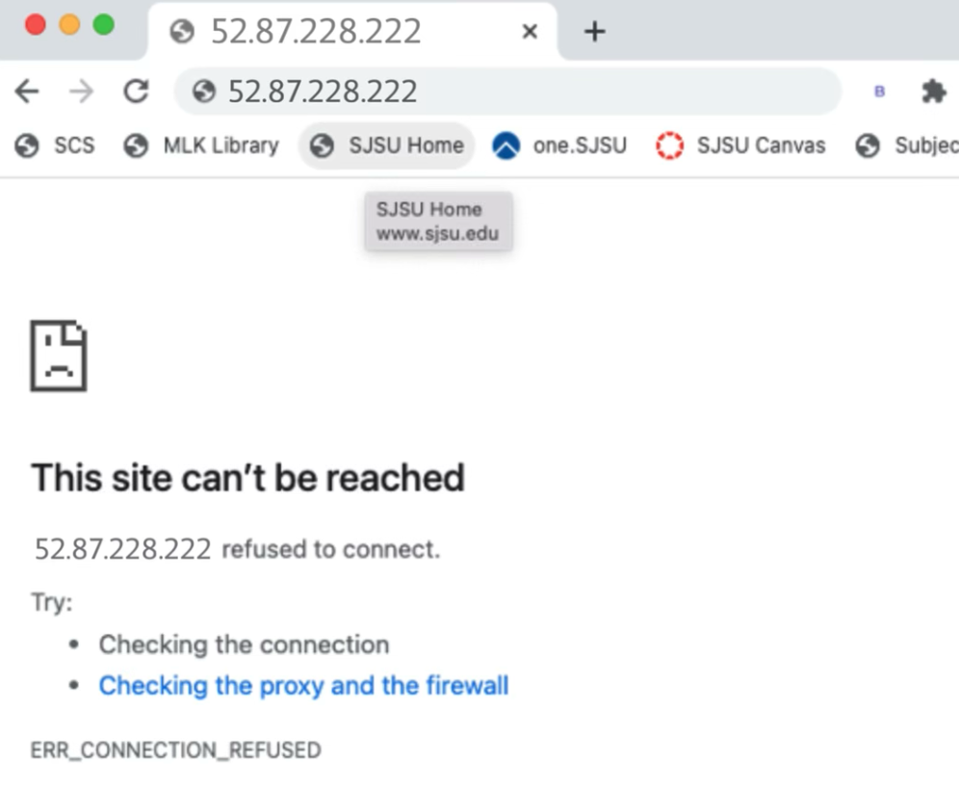

Apache is successfully undeployed.